# **Design your UI to display the water temperature, pH and turbidity monitoring system**

| **Date** | **11 November 2022** |
| --- | --- |
| **Team ID** | **PNT2022TMID51261** |
| **Project Name** | **Real Time River Water Quality Monitoring And Control System** |
| **Maximum Mark** | **6 mark** |

### Materials and system design :

The proposed domestic water temperature, pH and turbidity monitoring system consisted of a network of 3 sensors for collecting data on temperature, pH and turbidity of water. These sensors were connected to an Arduino microcontroller which processes the data before relaying it to a cloud platform through a Wi-Fi module. From the cloud platform, the information is pulled and displayed on a website. The authorities in charge are then able to monitor the data for the different water quality parameters as well as analyse the data in form of graphs. Should the data collected vary from the set standards, then the authorities are alerted instantly. Figure [1](https://bmcresnotes.biomedcentral.com/articles/10.1186/s13104-021-05578-9#Fig1) shows the block diagram of the proposed system.

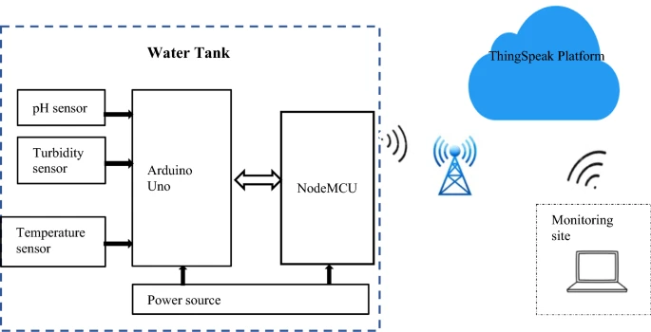

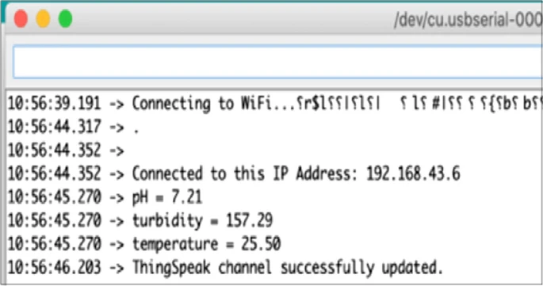

**PH Level:**

